Gabriel Martinez
WES 267B
Homework 2

Assignment 2 Report
The below report show the results and outputs from the lab and Homework 2. I modified the Makefile to run the solution executable with the GNU `time` command, making it convenient to verify the output and measure the program’s runtime with a single command.

Lab 2 Report: Loop unrolling
- How do we handle when there is not at least four elements remaining?
  - Answer: We have to manually loop through the elements. Case 1: if there’s less than four elements then we have to loop over the remaining elements in this case 0,1,2. Case 2: If there’s any amount over a multiple of four then we have to keep track of the index, i, such that we loop from i to the remaining number of elements in the array. Example, if there’s 7 elements then i=4 and have to loop 4,5,6.
- What is happening at the instruction level that may make this more efficient?
  - Answer: According to The Clang project docs, unrolling a loop reduces the loop control overhead and exposes more opportunities for instruction level parallelism [1].
Speedup was around .73s/.66s = 1.10x.

Loop output
The entire runtime was ~.73s.
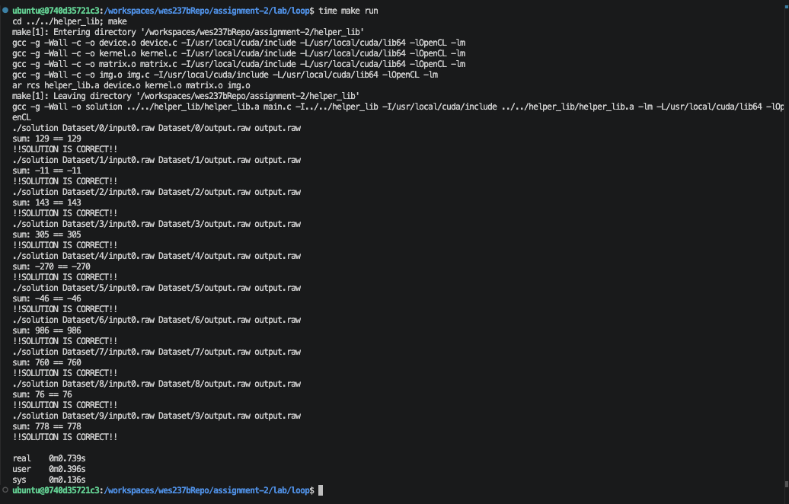
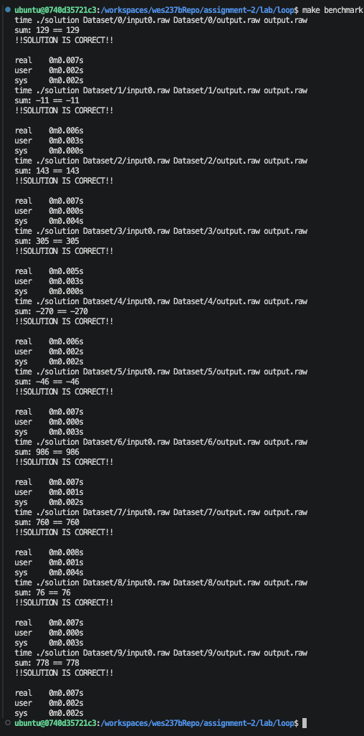

Loop unrolling output
The runtime for unrolling loop was ~.66s.
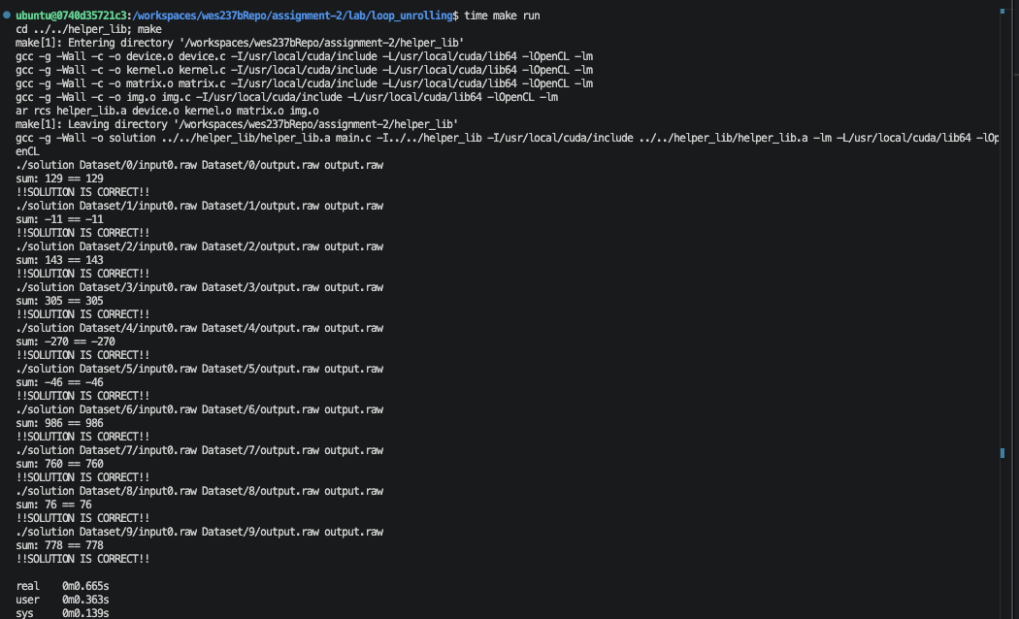
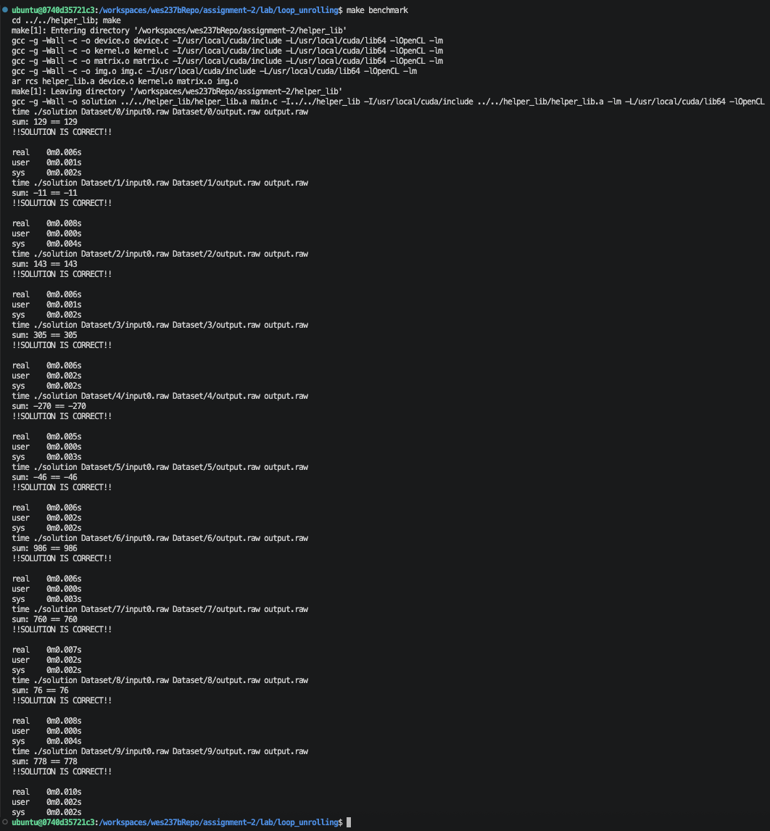

Homework 2: Report
Takeaway, the naïve matrix multiple took ~3min to run on my computer and the block matrix multiply fastest block size of 32 took ~48seconds overall with user ~46seconds and user ~.28seconds. According to Intel loop blocking (also known as loop tiling) is one of the most effective optimization techniques from the long list of possible loop optimizations you can apply to your code [2].
Speedup of Block matrix multiple to naïve matrix multiply was ~ 180/48= 3.75x.
We change the loop’s iteration space into smaller blocks to work with the memory hierarchy more efficiently in which we can guarantee that the data used in the loop will fit the cache until it is reused. This may significantly decrease the number of cache misses and improve the performance of the application. The Unrolled Block Matrix Multiply for block size 32 took ~44seconds overall user ~42s and sys ~.260s.
Speedup of unrolled block matrix multiply to block matrix multiple was ~ 48/44=1.09x. Overall speedup of unrolled block matrix multiply to naïve matrix multiple was ~180/44=4.09x.
Unrolled block matrix multiplication is faster for two reasons. Firstly, blocking improves cache reuse reducing expensive main memory accesses and cache misses. Secondly, loop unrolling reduces instruction overhead since four columns are calculated per iteration where one loop comparison, increment, and branch happens every four results instead of one. In addition, the four independent multiply/add operations give the CPU more opportunities for instruction level parallelism.

Naïve Matrix Multiply Output
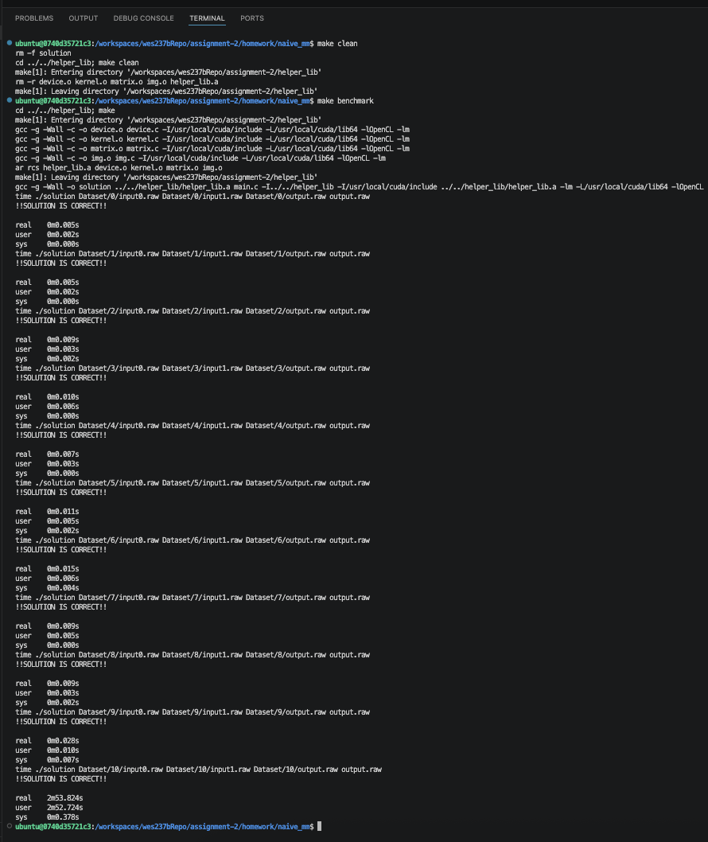

Block Matrix Multiply Output

8 Block Size
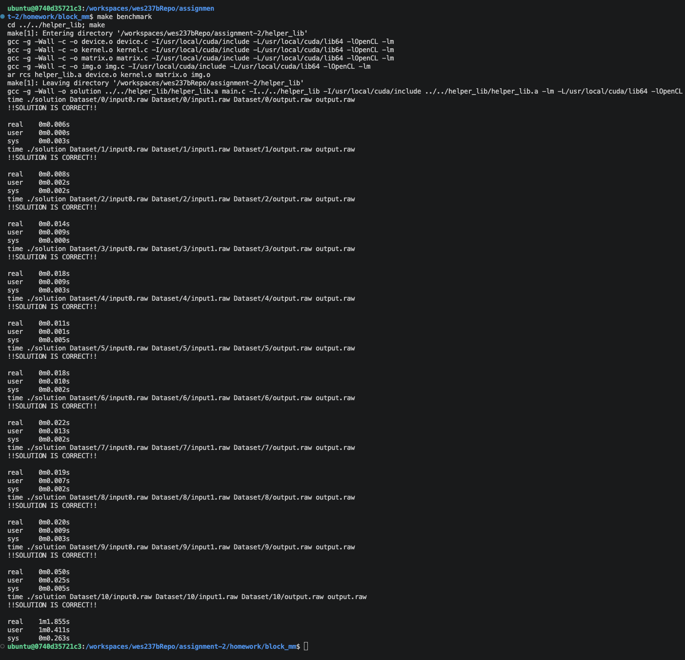

16 Block Size
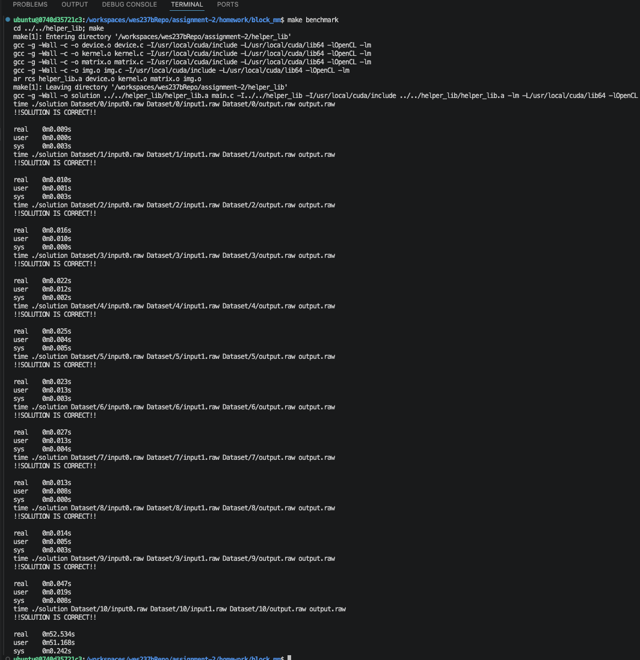

32 Block Size
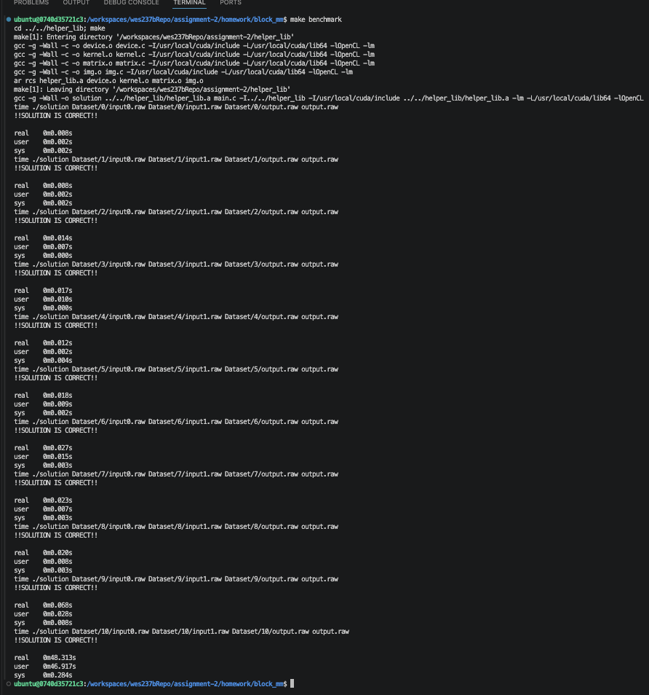

64 Block Size
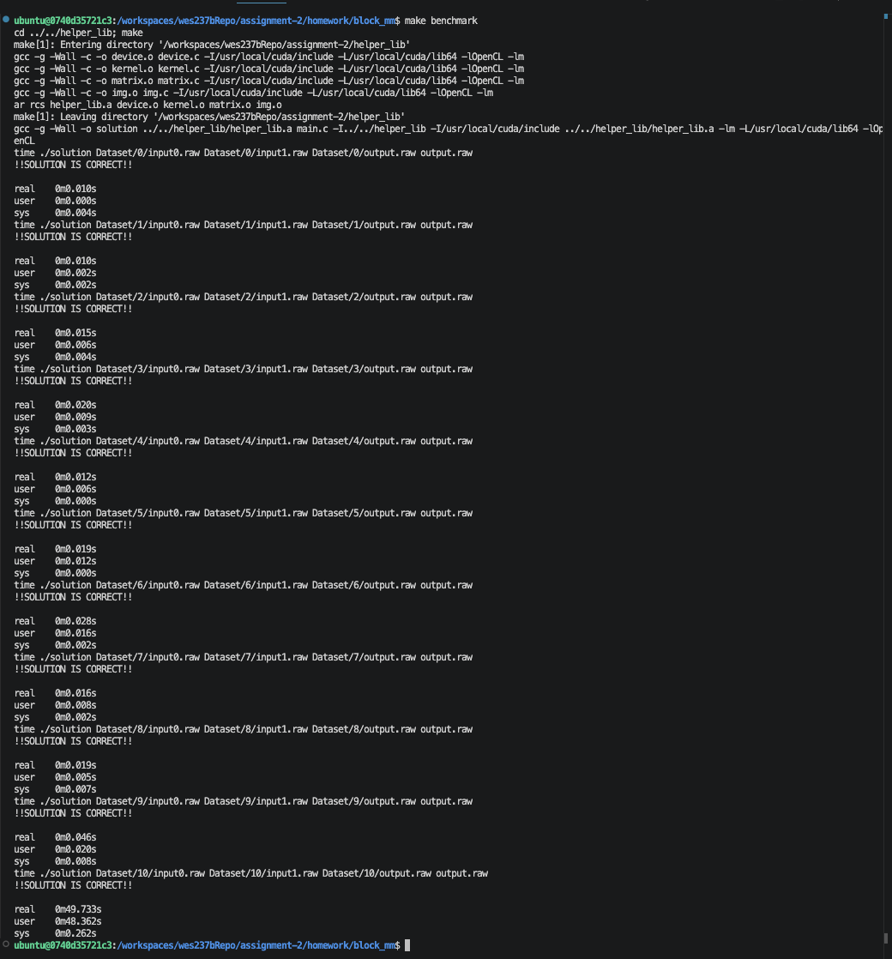

Block Size 128
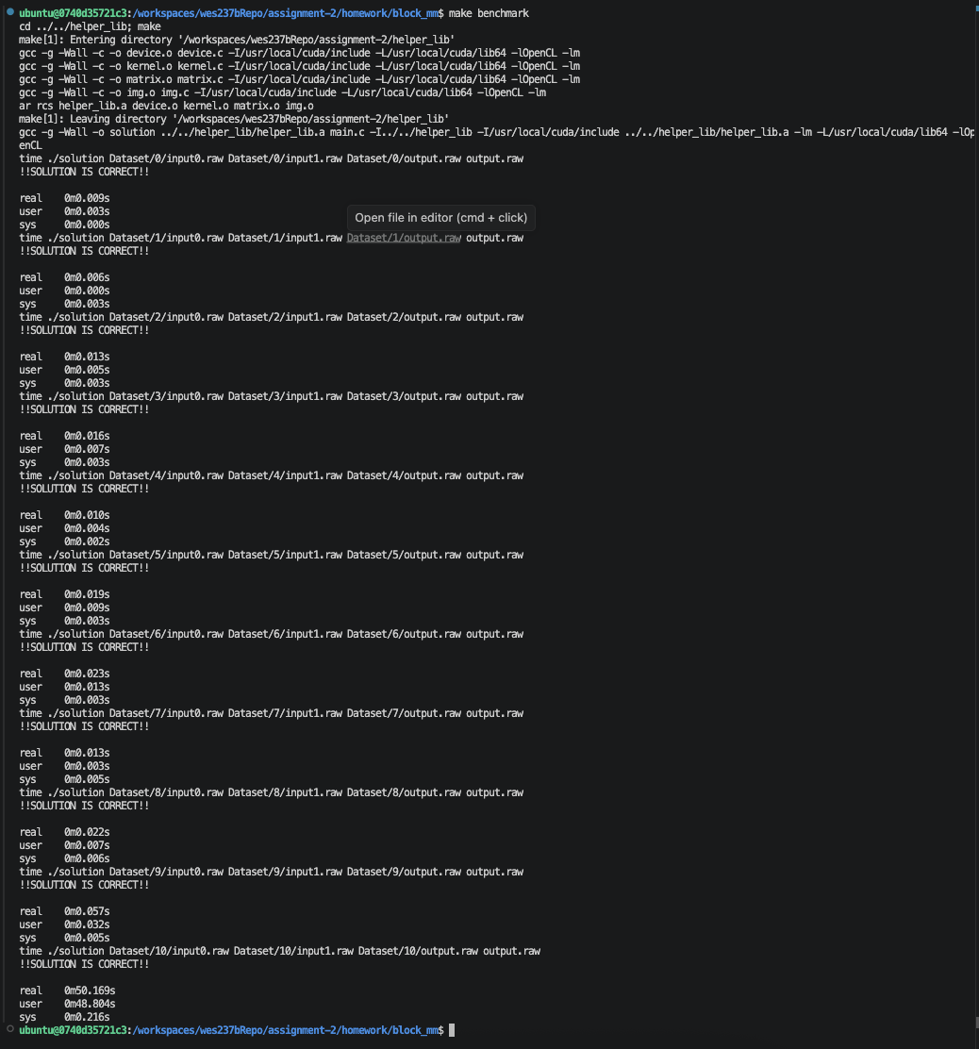

Block Size 256
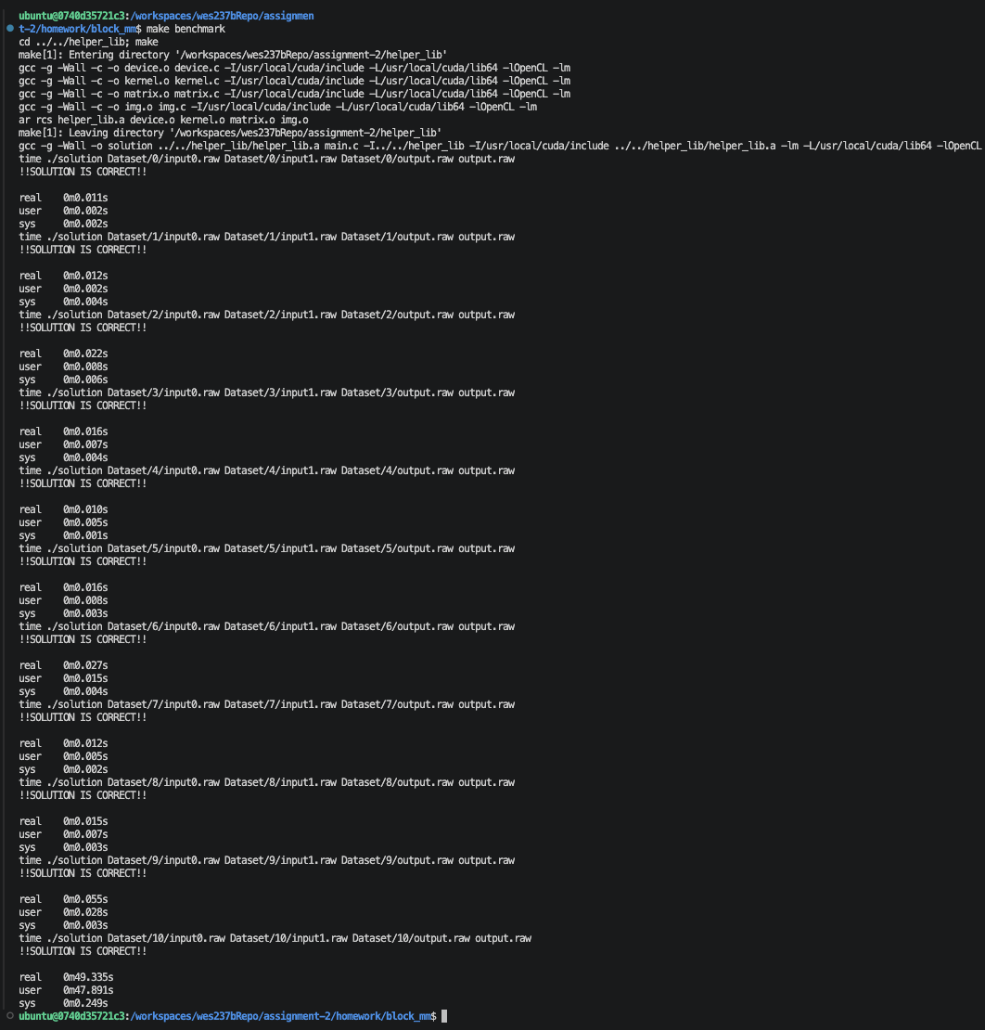

Block Size 1024
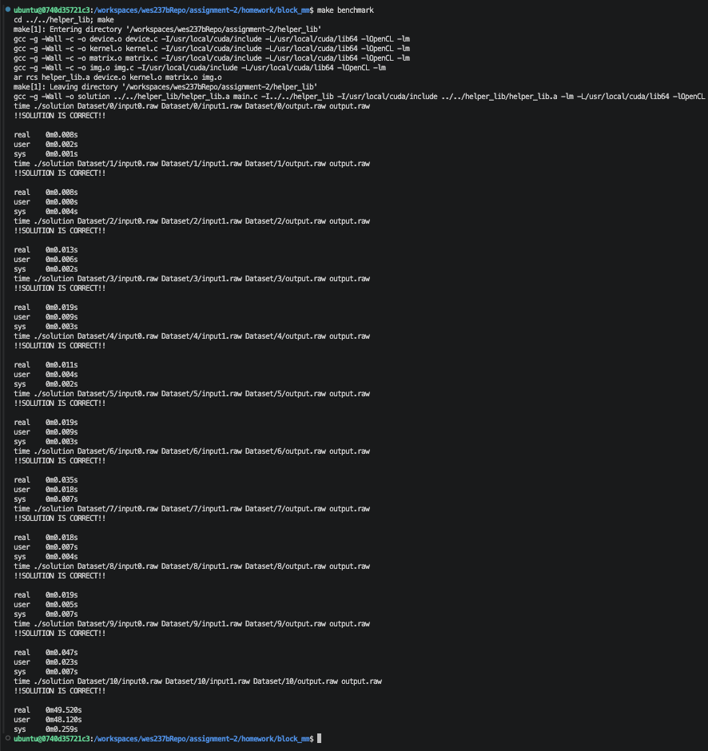

Unrolled Block Matrix Multiply Output Block Size 32
I selected a block size of 32 because it produced the fastest matrix multiplication runtime among the block sizes I tested from the previous section.
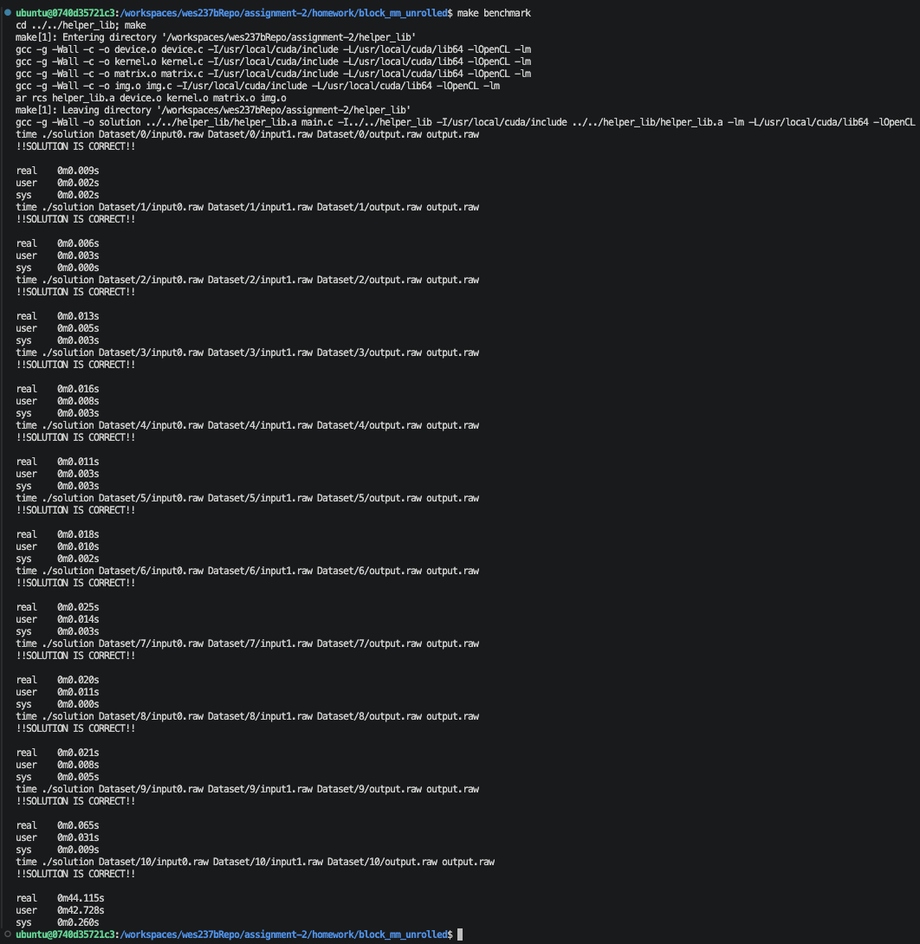

Works Cited

[1] | LLVM Project, "Clang Documentation," [Online]. Available: https://clang.llvm.org/docs/LanguageExtensions.html#loop-unrolling.
[2] | Intel, "Loop Optimizations Where Blocks are Required," [Online]. Available: https://www.intel.com/content/www/us/en/developer/articles/technical/loop-optimizations-where-blocks-are-required.html?utm_source=chatgpt.com.

